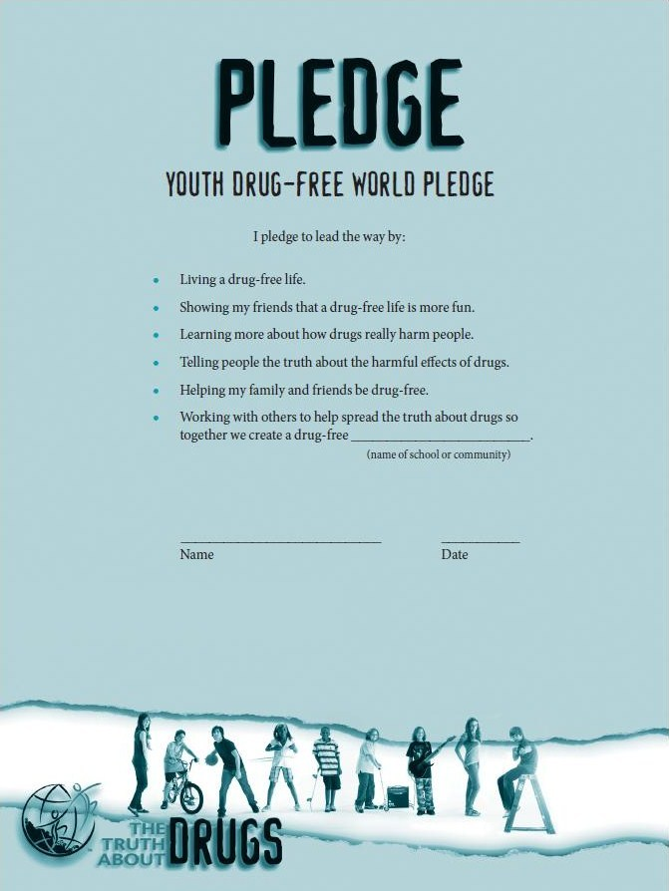
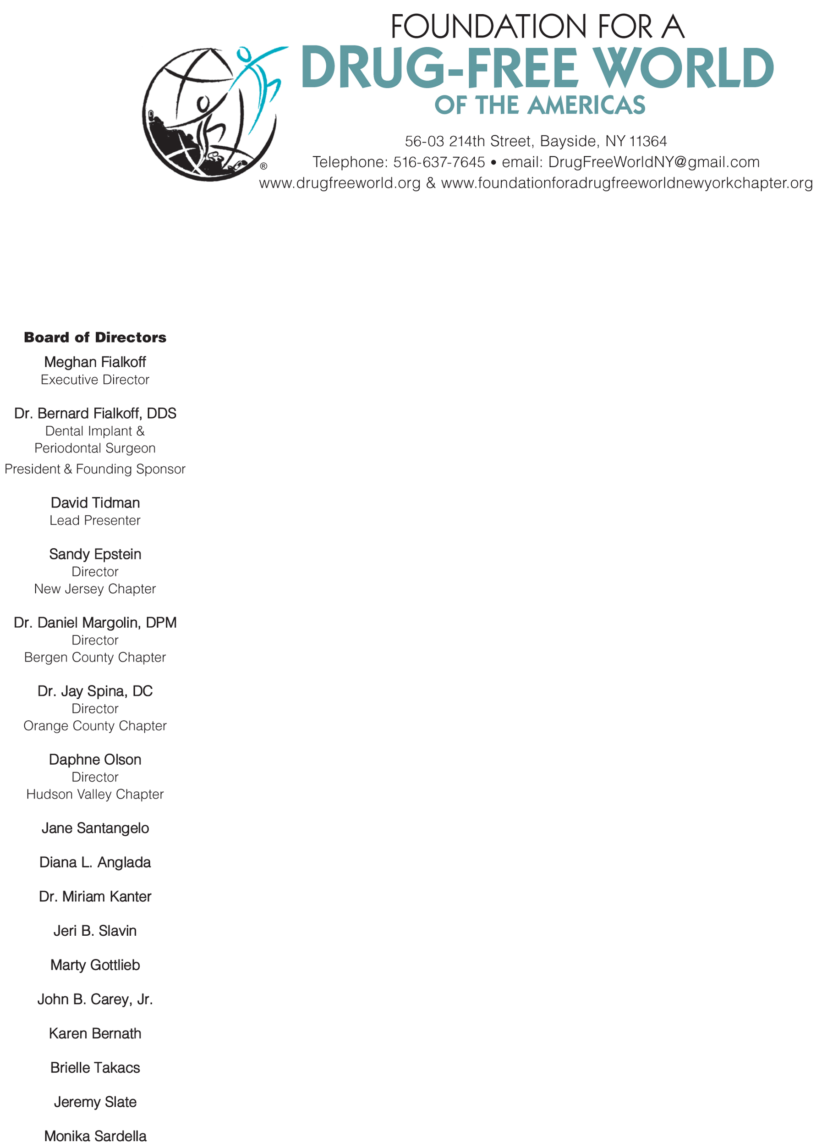
Dear Friend,

The Foundation for a Drug-Free World is a nonprofit public benefit corporation that empowers youth and adults with factual information about drugs so they can make informed decisions and live drug-free. No one, especially a young person, likes to be lectured about what he or she can or cannot do. Thus, we provide the facts that empower youth to choose not to take drugs in the first place. Through a worldwide network of volunteers and working with more than 800 police, government, and community partners and alliances, 62 million educational booklets have been distributed, tens of thousands of drug awareness events have been held, and public service announcements have reached more than 260 million viewers in 123 countries. These materials and activities have helped people around the world learn about the destructive side effects of drugs and thereby make the decision for themselves to not use them. The Foundation provides information you need to start a Truth About Drugs education and prevention activity in your area.
Dr. Bernard Fialkoff and Meghan Fialkoff founded the Americas Chapter in 2006 and since that time, their chapter has conducted free drug education events for 20% of NYC’s schools reaching more than 60,000 teens at more than 600 events. These events are part of our Truth About Drugs campaign that consists of activities that teens can join which popularize drug-free living.
ACTIVITIES
Our events consist of:
- Truth About Drugs Public Service Announcements & chapters from the Real Lives, Real Stories documentary DVD.
- Presenter goes over the definition of drugs, how drugs affect the emotions and body and the importance of goals, and has participants state their own personal goals.
- Youth Drug Free Pledge.
- Attendees sign/date and take home their own individual pledges.
- Distribute the Truth About Drugs booklets.
We also offer a free drug education curriculum entitled The Truth About Drugs Education Package as well as educator training workshops in which we train educators on the use and implementation of the curriculum.

OVERVIEW & MISSION
The Foundation for a Drug-Free World is a nonprofit public benefit corporation that empowers youth and adults with factual information about drugs so they can make informed decisions and live drug-free. No one, especially a young person, likes to be lectured about what he or she can or cannot do. Thus, we provide the facts that empower youth to choose not to take drugs in the first place. Through a worldwide network of volunteers and working with more than 800 police, government, and community partners and alliances, 62 million educational booklets have been distributed, tens of thousands of drug awareness events have been held, and public service announcements have reached more than 260 million viewers in 123 countries. These materials and activities have helped people around the world learn about the destructive side effects of drugs and thereby make the decision for themselves to not use them. The Foundation provides information you need to start a Truth About Drugs education and prevention activity in your area.
Dr. Bernard Fialkoff and Meghan Fialkoff founded the Americas Chapter in 2006 and since that time, their chapter has conducted more than 600 free drug education events for more than 60,000 people at schools, after-school programs, community centers, religious centers, etc. These events are part of the Truth About Drugs campaign that consists of activities that people can join which popularize drug-free living.
ACTIVITIES
Our events consist of:
- Truth About Drugs Public Service Announcements & chapters from the Real Lives, Real Stories Addy© Award winning documentary DVD.
- Presenter goes over the definition of drugs, how drugs affect the emotions and body, and the importance of goals-making.
- Youth Drug Free Pledge.
- Attendees sign/date and take home their own individual pledges.
- Distribute the Truth About Drugs booklets.
We also offer a free drug education curriculum entitled The Truth About Drugs Education Package as well as educator training workshops in which we train educators on the use and implementation of the curriculum.

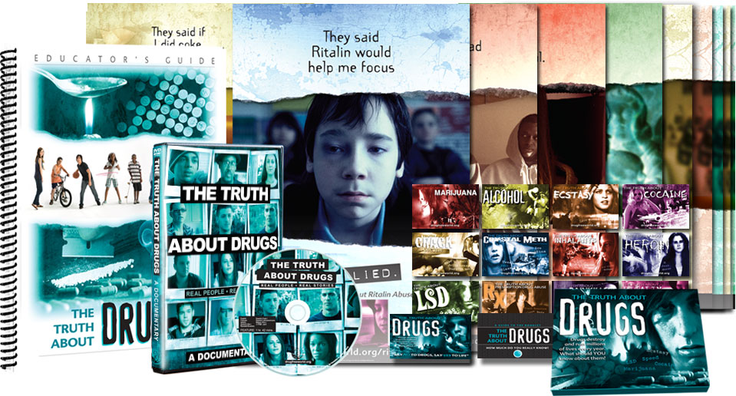

EDUCATIONAL MATERIALS
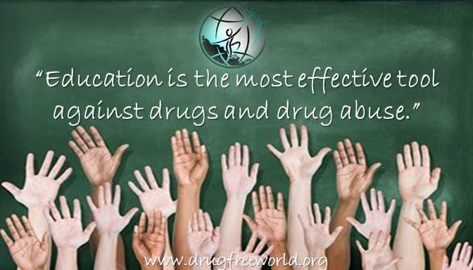

Educators can also order our educational booklets in bulk to distribute to students. Educators can distribute to students in the classroom, at school assemblies, at health fairs or open houses, local town meetings, PTA meetings, as part of national holidays such as “Red Ribbon Week,” and at other types of events or through one-on-one contacts. The assortment of educational booklets include: The Truth about Drugs, Marijuana, Alcohol, Rx Drug Abuse, Heroin, Cocaine, Ecstasy, Inhalants, Crack Cocaine, LSD and others. They are offered in more than 14 languages including Spanish, Korean & Chinese. At the end of each booklet, there is a bibliography citing the sources of information including such federal agencies as "National Survey on Drug Use and Health," "Office of National Drug Control Policy," "Partnership for a Drug Free America," "US Department of Health and Human Services," "UN Office on Drugs and Crime World Drug Report," among others.
Educators can also order our curriculum entitled “The Truth About Drugs Education Package.” The Truth About Drugs Education Package is offered as an aid to educators who teach 11-year-olds and above in a classroom, group instruction or community learning setting. The curriculum contains a lesson plan guide, documentary DVD, booklets and posters, as well as supplementary materials, in order to instruct on illicit drugs and their harmful effects.
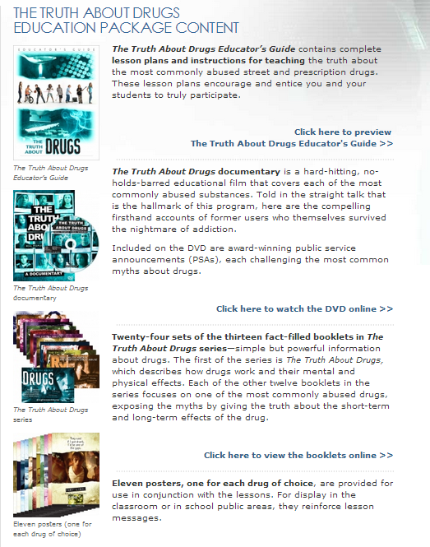

ACCOLADES, PARTNERSHIPS & OFFICIAL RECOGNITIONS
ACCOLADES, PARTNERSHIPS, OFFICIAL RECOGNITIONS, ETC.
- Eleven Proclamations from:
Congresswoman Grace Meng
Senator Rev. Ruben Diaz
Senator Jose Peralta
Senator Tony Avella
Assemblyman Felix Ortiz
Manhattan Borough President Gale A. Brewer
Orange County, County President Steven M. Neuhaus
Mayor of the City of Middletown, NY Joseph M. DeStefano
Council Member Paul Vallone
Assemblywoman Nily Rozic
Council Member Dan Halloran
- Miss New York is a special guest speaker for the foundation and presents at many of the foundation’s events throughout NYC.
- The foundation has provided resources for: New Jersey Attorney General’s Office of Consumer Affairs, NYC Office of the Mayor’s Staten Island Borough Director, NYPD Office of School Safety, NYPD Explorers, NYPD Community Affairs Bureau, NYPD Youth Police Academy, NYC Department of Youth and Community Development (DYCD), NYC Department of Education SAPIS (substance abuse counselors) Manhattan branch, Spanish American Medical Dental Society, among others.
- Member of the New York Senate’s Task Force on Heroin and Opiate Addiction
- Great Non Profits awarded the foundation the Top Non Profit award in 2013.

DRUG FREE HEROES AWARDS GALA
Each year, the Americas Chapter as well as chapters around the world, observe the United Nations’ International Day Against Drug Abuse. Since 2007, we have held an annual Drug Free Heroes Awards Gala, honoring those community leaders who make the biggest difference in drug prevention and education. Past Drug Free Hero Awardees include:
2008 - The Ability School Drug Free Marshal Students
2009 - Scot Anthony Robinson, "The Vision Warrior"
2009 - Sergeant John Crowley of the NYPD's Midtown North Precinct
2009 - Latoya Hall, Service & Learning Center Adviser, and the Students of Stanley M. Isaacs Neighborhood Center
2010 - NY State Senator Rev. Ruben Diaz
2010 - NYPD Police Officer Iris Mercado
2010 - Sandra Marquez of Volunteers of America
2010 - Sherry Thomas of Veritas, Inc.
2010 - NYPD Retired Narcotics Detective Michael Zotto, and Founder of Strategic Protection Group
2010 - Rachel Murphy, NY State Office on Alcoholism on Substance Abuse (OASAS) "Your Story Matters" Campaign Director Rachel's "Your Story Matters" Campaign web site: http://www.iamrecovery.com/ from OASAS (New York State Office on Alcoholism and Substance Abuse)
2011 - Rachel Cook, Youth Empowerment Director Madison Square Boys & Girls Club’s Thomas S. Murphy Clubhouse
2012 - Mayra Gonzalez, Westhab’s Elm Street Resource Community Center
2012 - Lance & Todd Feurtado, King of Kings Foundation
2012 - Erica Ford, Life Camp, Inc.
2012 - Jermaine Perry, New York Youth at Risk
2012 - Latoya White, Alcoholism Council of NY
2013 - Paul Gammarano, Professor, Kingsborough College
2013 - Jarlene Jacome, Flushing YMCA
2013 - Helson Santiago, Bronx Substance Abuse Counselor & Educator
2013 - Monifah Bittings, Countee Cullen Community Center, a Program of the Harlem Children's Zone
2013 - Sergeant James Clarke, New York City Police Department, Community Affairs Bureau
2013 - Raymond Reid, Elm Street Youth Center, Yonkers
2013 - Michael Spinelli, Strategic Protection Group
2013 - Sharon Riley, Center for Family Guidance
2013 - Dr. Bernard Fialkoff, Founder, Queens Chapter, Foundation for a Drug Free World
2013 - Altagracia Medina, Hackensack High School, Health Education Teacher
2013 - Tanaya Bruce, Hackensack High School, Health Education Teacher & RN
2013 - Lisa Barrett, Genesee Council on Alcoholism & Substance Abuse - Lisa's music video "Everyday Hero" here: http://www.youtube.com/watch?v=xK5--CFn51Q
2014 - Matty Prawicka, Addiction Intervention Recovery (A.I.R.)
2014 - Sergeant Liza Aviles, NYPD Community Affairs Bureau
2014 - Katarzyna Selwesiuk Swietochowski, North Brooklyn Development Corp, After School Program at PS 110
2014 - Tameek "Teemonee" Williams, Musical Artist & Creator of the Anti-Drug Theme Song "Purpose"
2014 - Stanley Romulus, Good Shepherds
2014 - Tiffany Williams, YMCA Y Roads Center
2014 - Madonna Donaldson, Police Athletic League
2014 - Detective Patrick Blanc, NYPD Community Affairs Bureau & Embrace Ya Kidz "EYK"
2014 - Officer Luis Hermenegildo, NYPD Community Affairs Bureau
2014 - David G. Evans, Drug Free Schools Coalition & Special Advisor to the Drug Free America Foundation and Save our Society from Drugs
2014 - Honorary Hosts - ASA College Criminal Justice Students
2014 - Honorary Host - Monifah Bittings of Wonderfully Created Works
2014 - Honorary Host - Carlos Manuel Perez Gonzalez of Parroquia Cristo Rey and Consejo Nacional de Drogas, Dominican Republic
2014 - David Tidman, Queens Chapter Lead Presenter of Foundation for a Drug Free World, honored with special award "Drug Free Leader"
OVERSEAS WORK
The National Council on Drugs (Consejo Nacional de Drogas) invited the Foundation for a Drug Free World of The Americas to the Dominican Republic to train the National Council of Drugs on the foundation's program and curriculum. The Council had learned of the foundation earlier in the year after a visit by one of their drug counselors to our New York office. After viewing our Truth About Drugs Education Package (curriculum), attending the Drug Free Heroes Awards Gala and learning about the foundation's work in the Northeast of the United States, the National Council on Drugs was eager to bring the drug education program to the Dominican Republic. The executives and staff of the Foundation for a Drug Free World of The Americas chapter visited the Dominican Republic and partnered with the National Council on Drugs, signing an agreement for national implementation of the foundation’s program. Every drug counselor in the National Council on Drugs received a Spanish curriculum for their use in educating children, teens and adults throughout the country, and was trained on its use.
- - -

To learn more about the Foundation for a Drug Free World International, please visit: www.drugfreeworld.org
To learn more about the Foundation for a Drug Free World Americas Chapter, please visit:
www.foundationforadrugfreeworldnewyorkchapter.org



